**Apple iTunes Music Analysis**

**Problem Statement**

Apple iTunes maintains a large digital music store with millions of tracks, thousands of customers worldwide, and a network of employees managing sales operations. As the business expands, the leadership team is looking to gain deeper insights into customer behavior, music preferences, and overall sales performance.

As a Data Analyst, I am tasked with analyzing the iTunes relational database (provided in CSV format) to generate actionable insights that can help improve product offerings, customer targeting, and operational efficiency.

My role is to build a complete SQL-based analytical pipeline using the available datasets, which include details about customers, employees, invoices, tracks, albums, artists, genres, playlists, and media types.

### **Business Goals**

1. Understand customer behavior and purchasing trends.
2. Identify the most and least popular music genres, tracks, and artists.
3. Evaluate sales performance by employees and customer regions.
4. Analyze revenue trends across time and product types (media types).
5. Uncover growth opportunities by identifying underutilized content or inactive customers.

### **1. Customer Analytics**

A. Customers who spent most money on music:

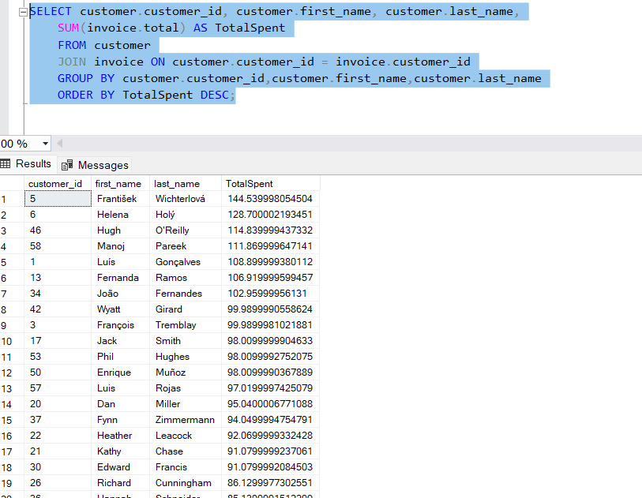

**Insight:**

This SQL query identifies customers who have spent the most, with "František Wichterlová" being the top spender at $144.54, followed by "Helena Holý" at $128.70.

**B. Average Customer Lifetime Value:**

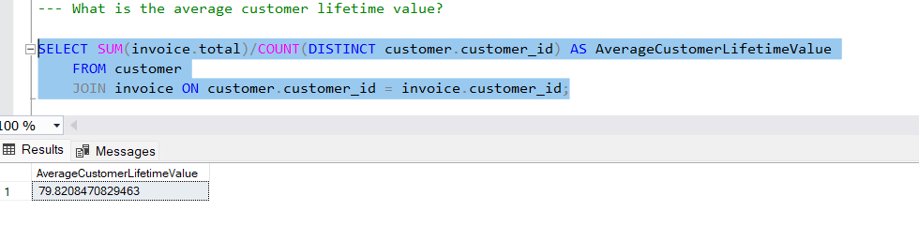

**Insight:**

The average customer lifetime value, calculated by summing individual customer totals and then averaging them, is $79.82.

**C. Repeat customers:**

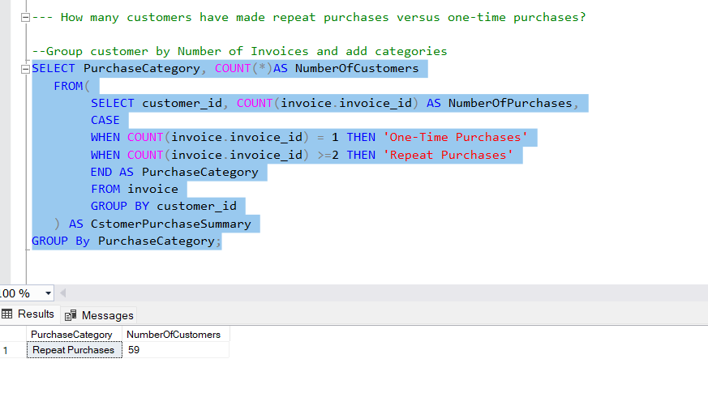

**Insight:**

It shows that there are 59 repeat customers, identified by having more than one invoice.

**D. Countries who generates the most revenue per customer:**

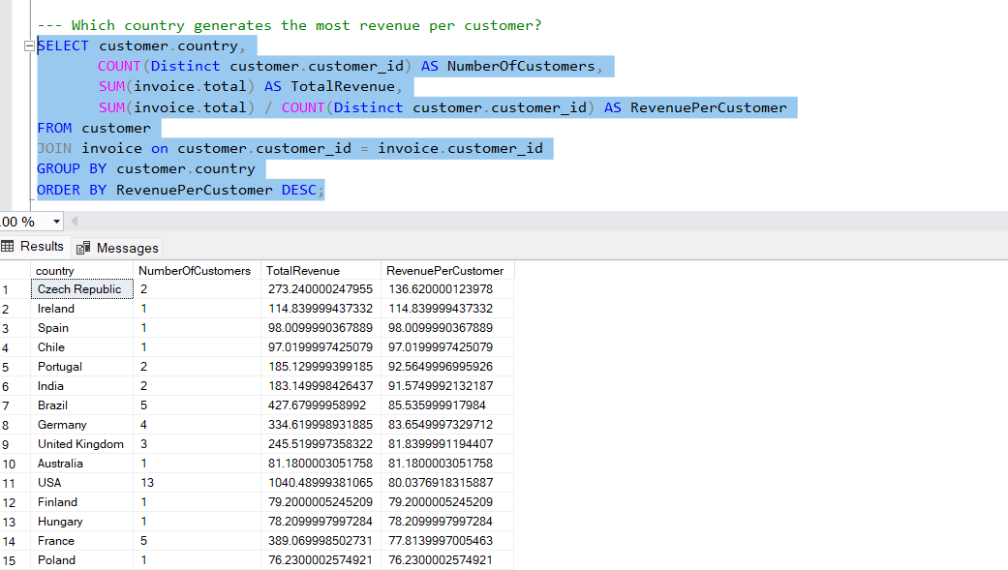

**Insight**:

This query results show the "Revenue per Customer per Country" and indicate that the Czech Republic has the highest revenue per customer at $136.62, followed by Ireland at $114.84.

**E. Customers inactive in last 6 months:**

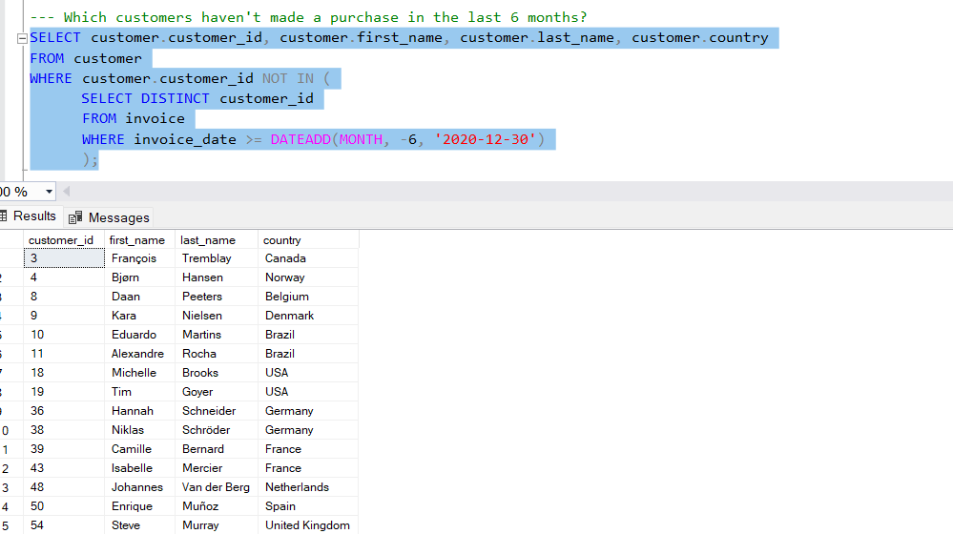

**Insight**:

This list presents 16 customers who are inactive for last 6 months.

### **2. Sales & Revenue Analysis**

**A. Monthly revenue trends for the last two years:**

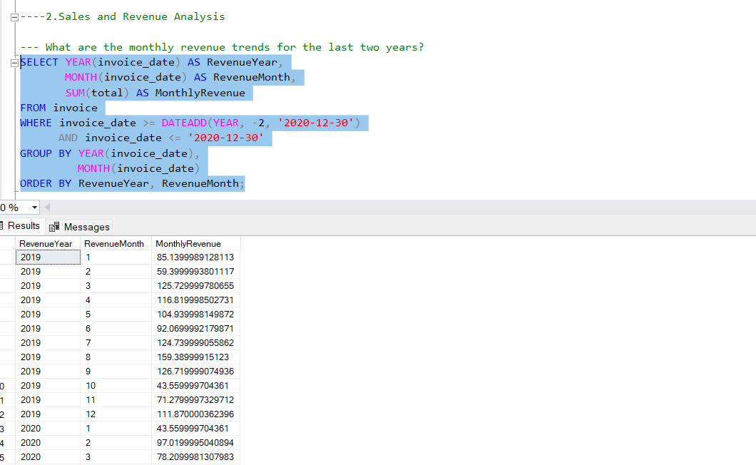

**Insight**:

The query displays monthly revenue starting from January 2019, showing fluctuations with a high of approximately $159.39 in August 2019 and a low of $43.56 in October 2019 and January 2020.

**B. Average Invoice Value:**

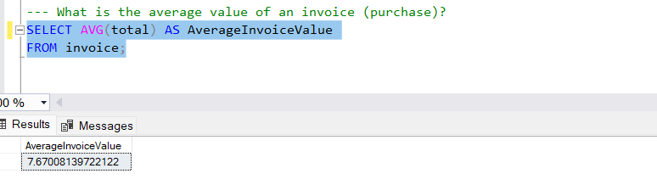

**Insight**:

The average invoice value, rounded to two decimal places, is $7.67.

**C. Months or quarters have peak music sales:**

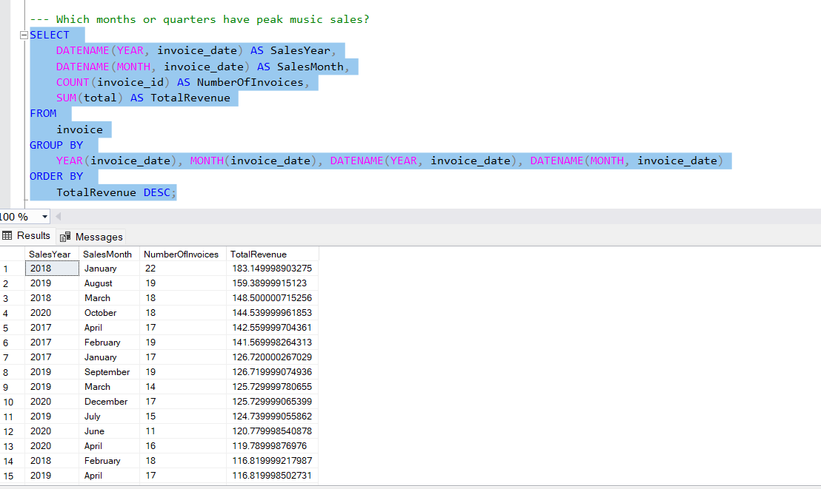

**Insight**:

The query identifies the top 5 peak sales months, with January 2018 having the highest revenue at $183.15, followed by August 2019 at $159.39.

### **3. Product & Content Analysis**

**A. Tracks with Most Revenue:**

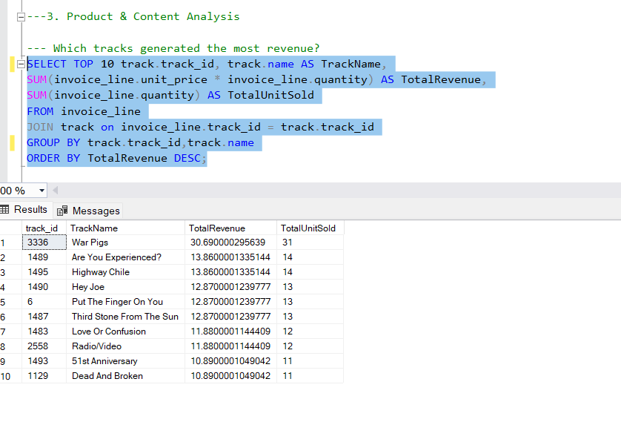**Insight**:

The query identifies the top 10 tracks by revenue, with track ID 3336, track name War Pigs generating the highest revenue of 30.69, significantly more than the subsequent tracks.

**B. Most purchased Playlist:**

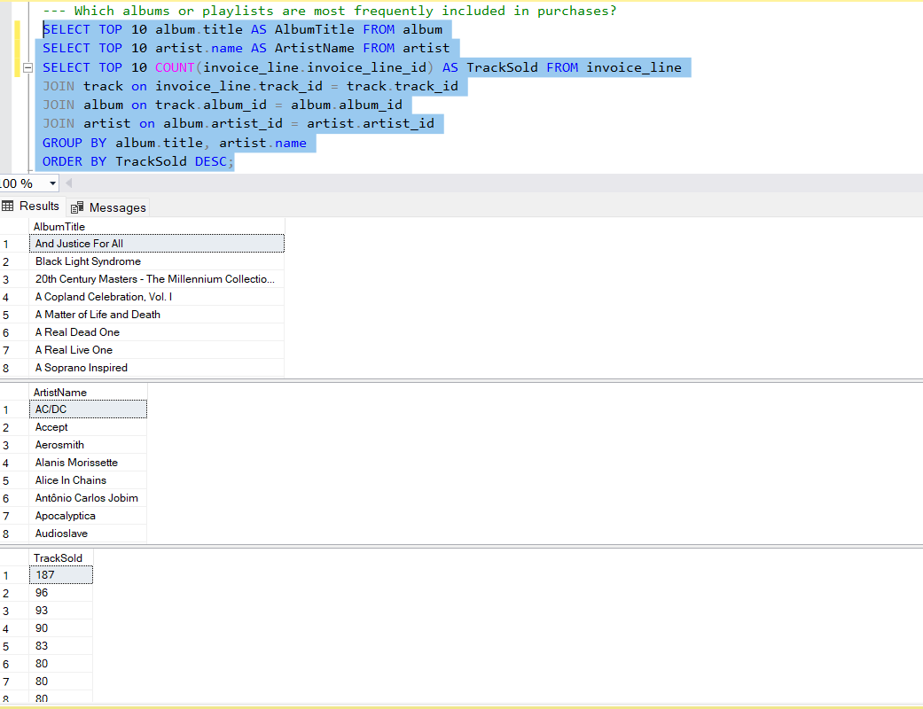

**Insight**:

The query results reveal that "And Justice For All" is by far the most purchased playlist with 187 purchases.

**C. Tracks Never Purchased:**

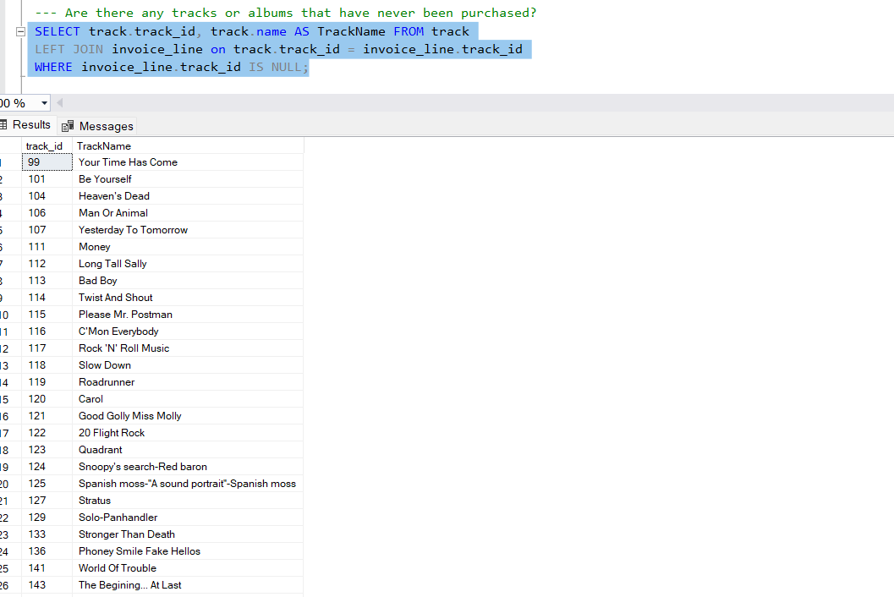

**Insight**:

The query successfully identifies a list of track IDs, starting from 99 and continuing sequentially, that have never been purchased.

**D. Average Price per Track across different Genres:**

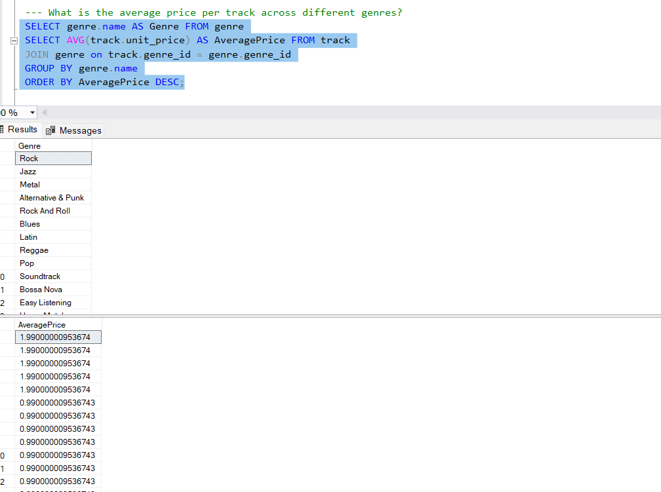

**Insight**:

The query successfully identifies the average price per track across different genres starting from Genre name Rock.

### **4. Artist & Genre Performance**

**A. Top 5 Highest Grossing Artists:**

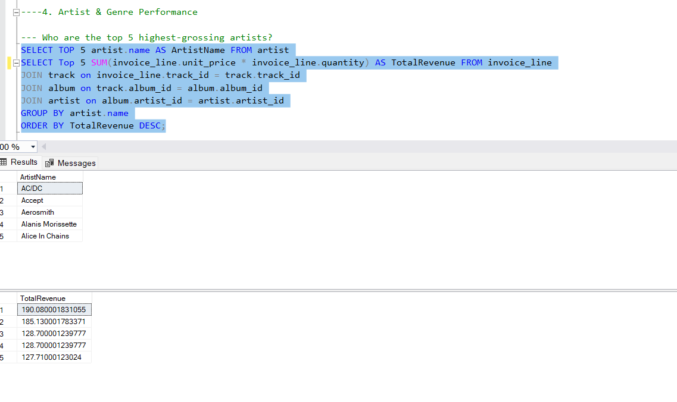

**Insight**:

The query successfully identifies a list of Top 5 artists who have earned highest gross income.

**B. Music genres are most popular in terms of:**

Number of tracks sold

Total revenue

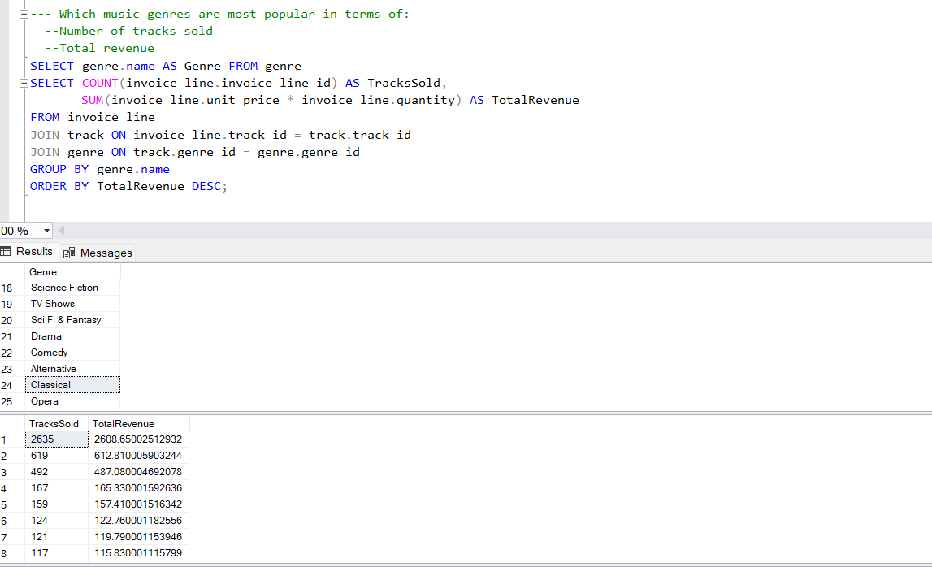

**Insight**:

The query successfully identifies a list of most popular genres by number of track sold and total revenue. Science Fiction is the highest purchased genre in terms of number of track sold and total revenue.

### **5. Employee & Operational Efficiency**

**Employees who have managing the highest spending customers:**

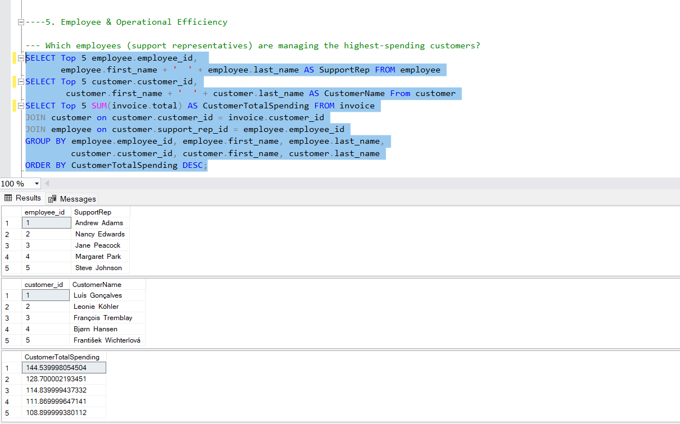

**Insight**:

The query successfully identifies a list of top 5 employees who are managing the highest spending customers.

1. **GEOGRAPHIC TRENDS**

**Highest Number of Customers by Country or City**

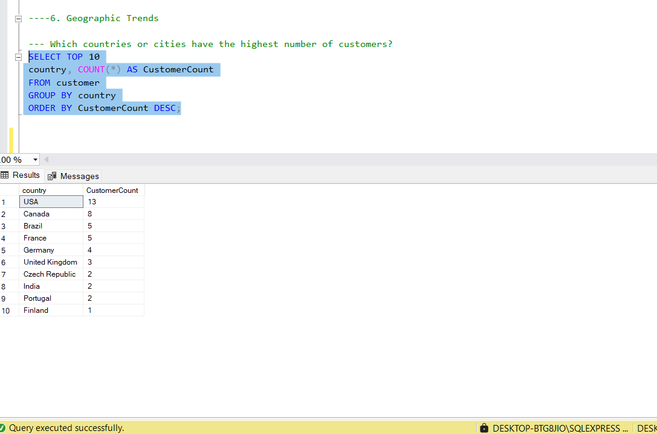

**Insight**:

The query results indicate that the USA has the highest number of customers (13), followed by Canada (8), and then Brazil and France (both with 5 customers each)

### **Operational Optimization**

1. **Price vs Sales Analysis:**

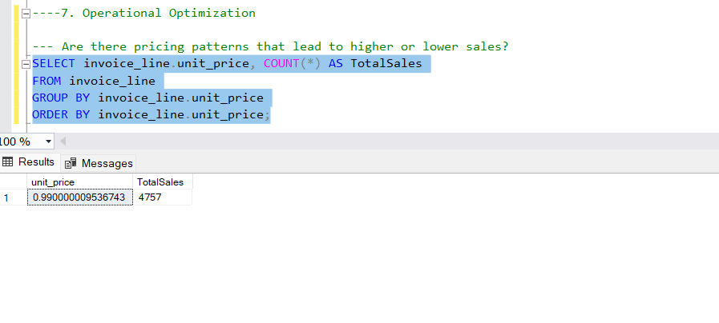

Insight:

The query reveals that items priced at $0.99 account for the vast majority of sales, with a total of 4745 units sold at this price point.

1. Usage of Media Type:

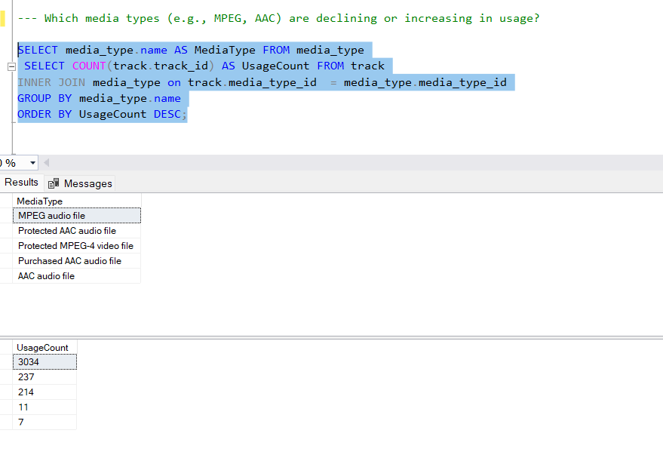

**Insight**:

The query reveals the usage count of media type.MPEG audio file was highest used media type.

**Conclusion:**

The analysis highlights that top customers like František Wichterlová and Helena Holý significantly impact revenue, while the USA leads in both customer base and revenue generation. Operational efficiencies show that $0.99-priced items are the most popular, contributing substantially to overall sales. These insights underscore the importance of customer segmentation and pricing strategies in optimizing revenue. Moving forward, focusing on high-value customers and refining product offerings could further enhance profitability and operational effectiveness in the market.